ND YAG LASER
TATTOO REMOVAL MACHINE
MODEL：J-303T

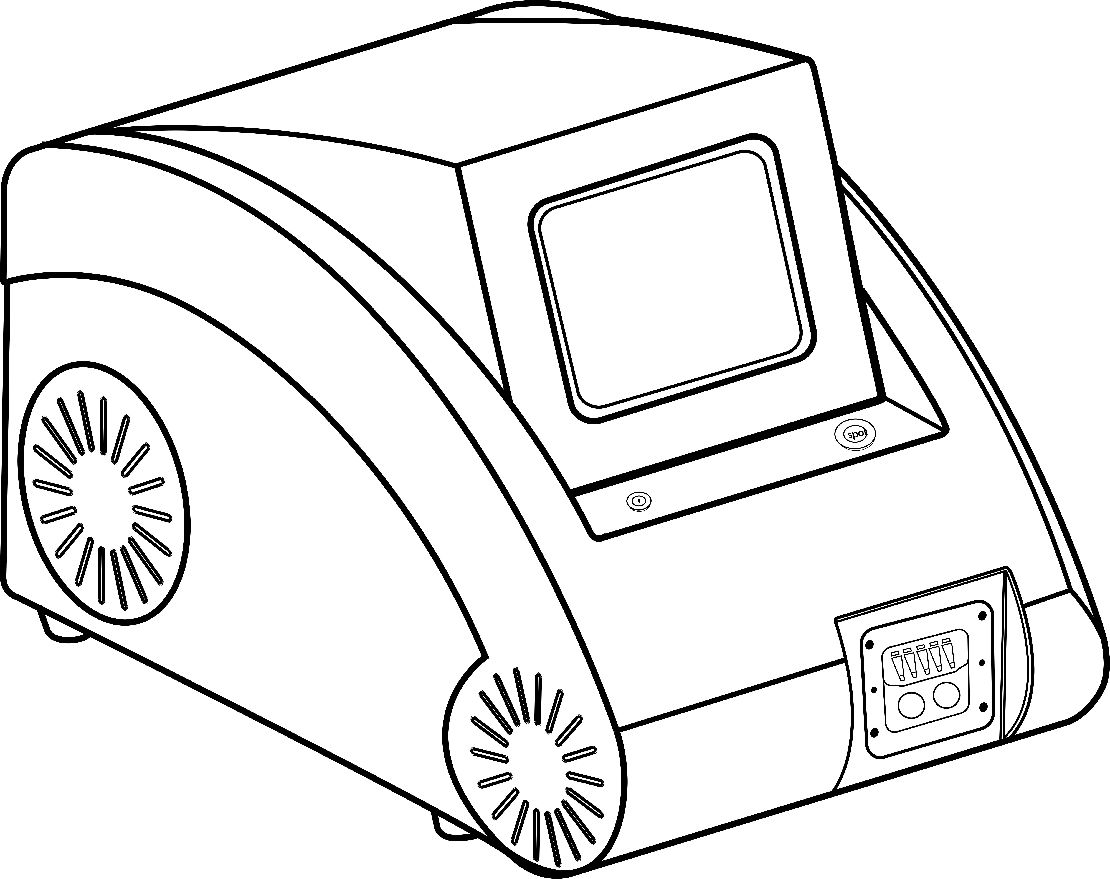

Use manual

Preface
Thank you for choosing the instruments carefully designed and manufactured by our company. In order to better utilize the products, we sincerely recommend:
- Before using the instrument, please read these instructions carefully and keep them in a safe place for future reference.
- Please install, use and operate correctly according to the instructions in the instructions.
- Do not disassemble and modify any parts of this unit。
- Except for authorized personnel of the company, it is strictly forbidden to open the cover and disassemble the main unit.
- It is strictly forbidden for non-professionals to perform maintenance and renovation without authorization.
- If you encounter any difficulties during the operation, please contact us.

Never look directly at the glare from the front exit of the bald hand

1、Product introduction

Nd yag laser tattoo removal machine is a multi-functional beauty instrument that uses the most advanced optical technology in the field of beauty technology. It combines the multi-wavelength optical energy to fully exert the light energy effect and has significant clinical effects. It has been proven to be safe and effective for different applications.

2、Technical principle
Nd yag laser tattoo removal machine uses the jewel Q-switching mode, the high-energy energy is used to effectively break down the pigment in the diseased tissue. That is, the principle of photo-blasting: the accumulated high-energy instant emission causes the irradiated pigment particles to absorb energy and then expand and rupture, and a part of the cracks become more tiny particles excreted, and some are excreted by the human body through the lymphatic system, thereby removing the pigment. The surrounding normal tissue does not absorb the 1064nm, 532nm laser, thus maintaining the integrity of the cell frame, and there is no condition for scar formation. The maximum degree of safety is guaranteed to be free from complications after use.
3、Scope of application
Exogenous pigmented skin problems: the operation of pigmented skin lesions such as tattoos, eyebrows, eye lines, lip lines and traumatic tattoos has good clinical results.
With the toner operation head, black face dolls and white porcelain dolls can be developed to achieve skin rejuvenation, fine pores, lightening spots, whitening, blackhead and oil control.
4、technical parameter
Wavelength：532nm、1064nm、1320nm
Pulse width：10ns
Energy：20--2000mj
Working frequency：1-10Hz
Spot diameter：1-8mm
Cooling method: water cooling + air cooling
Total power：300W
- Instrument display

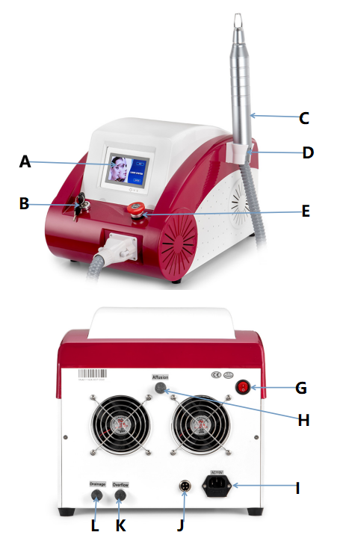
A: Screem，B: Power Switch, C: Handle, D: Handle bracket, E: Emergency Switch，
G: Red sight switch，H: Water injection hole,I: Power interface,
J : Foot switch interface,K:Overflow hole,
L:Drain hole

6、Instrument list
Host: 1 set
Handle: 1 piece
Handle probe：532nm、1064nm and 1320nm
Handle hanger: 1 piece
Hanging screw: 2 pieces
The opening key: 2 pieces
Safety glasses: 1 pair
Goggle: 1pair
Water injection funnel: 1 piece
Foot switch: 1 piece
Carbon: 1 piece
Seal ring：3 piece
Power Line: 1 piece
Manual: 1 piece
Please check the equipment list according to the instrument list immediately after unpacking. If you find any missing or damaged items, please contact us within 24 hours.
7、Instrument installation
7.1 Rack mounting
Remove the hanger screws and fix the hanger to the side of the instrument;
7.2 Handle installation
Remove the water nozzle sealing rubber sleeve, corresponding to the handle interface, insert the handle insertion and extraction member into the host interface, and tighten the screw on both sides of the insertion and removal member;
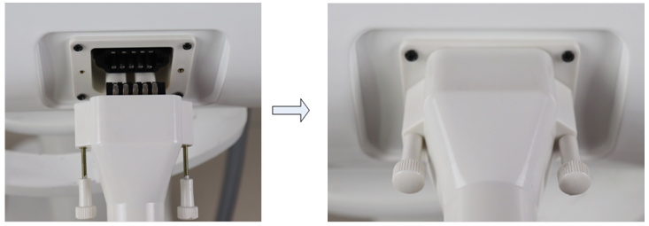
7.3 Instrument adding water
Screw the water injection funnel to the water injection port, open the overflow sealing cap, add purified water distilled water, add water to the overflow, and stop adding water;
Note: The sealing cap of the water filling port and the overflow port is to prevent the internal residual water from flowing out during the transportation of the instrument and to wet the instrument; however, when the instrument is working, it is forbidden to screw the sealing cap of the water inlet and the overflow, otherwise the water circulation will be affected. The water temperature is too high and it is easy to burn the handle.
7.4 Instrument debugging
Connect the foot switch to the instrument;
Plug in the power cord and power on;
Insert the key and turn the key switch clockwise;
Turn the emergency stop switch clockwise；
8、Instrument operation
8.1 Turn on the instrument and enter the boot interface

8.2 Click on the boot interface to enter the operation interface.
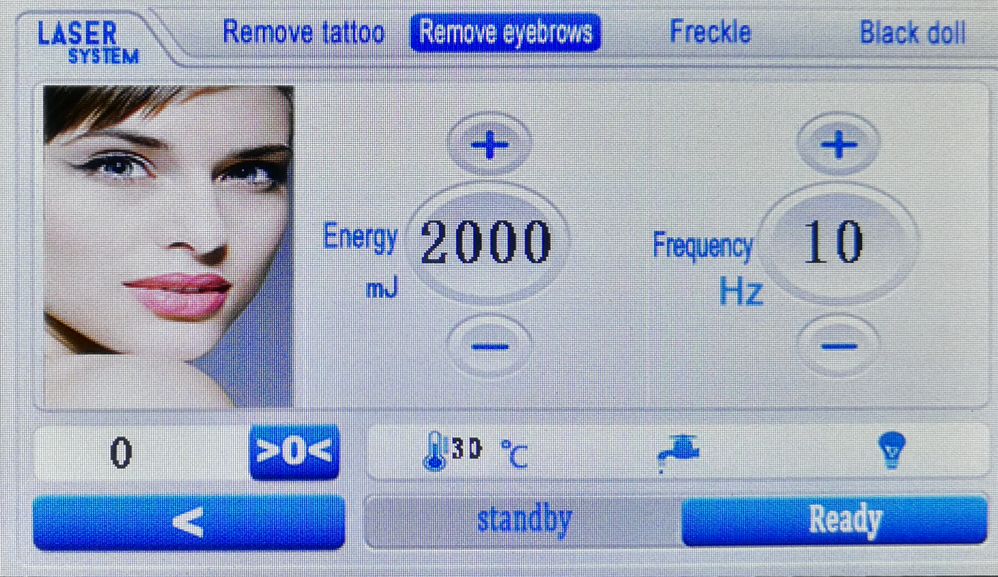
8.3Operation interface description
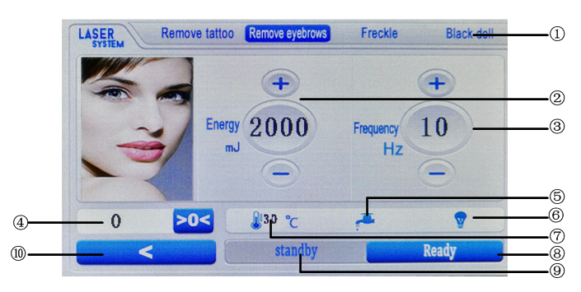
①Operating item ②Energy adjustment ③Frequency adjustment
④ Shot Times ⑤Water flow status ⑥Power status
⑦Water temperature status ⑧Standby button ⑨Ready button ⑩Return button

Never look directly at the glare from the front exit of the bald hand.
9、Operational knowledge
9.1 Taboo crowd
- heart disease, high blood pressure patients
- pregnant women, patients with epilepsy
- Hypertension, diabetes patients
- light allergy customers
- Long-term work under strong light, recently sunburned skin
- Short-term skinning customers
- Customers who are taking antioxidants or hormonal drugs
10、Precautions
10.1 Handling safety
- The instrument has a precision memory device, and the user should try not to move it at a long distance.
- Before transporting the machine, the water in the instrument must be cleaned, and the water inlet, overflow and drain sealing caps should be tightened;
- Remove the handle, seal the two nozzles of the main plug and insert, avoid the residual water stain inside the instrument, and wet the instrument;
- The shock absorb package provided by the original factory must be used during transportation, otherwise the optical system may be out of adjustment and affect the energy output.
10.2 Electrical Safety
There is a high voltage in the running time of the instrument. After the power is turned off, the high voltage device may still have residual voltage. There is a danger of high voltage electric shock when the chassis is opened at will!
10.3 Operational safety
- You must fill up the water before starting the machine, otherwise it will burn the treatment hand! And use pure water or medical distilled water.
- Check the circuit and water circuit of the instrument immediately after turning it on, and observe the safety of the circuit and waterway from time to time throughout the operation.
- Never look directly at the glare from the front exit of the bald hand.
- Reflective substances such as watches, mirrors, jewelry, etc. are prohibited in the treatment room.
- Keep the light guide system clean at all times and ensure that the cold gel does not contaminate the light guide system.

10.4、Routine maintenance
1 Cleaning the handle probe: After using the instrument for a period of time, the lens of the handle probe should be inspected and cleaned regularly; during the operation, the splash of pigment particles in the tissue splashes on the lens of the probe, which affects the light of the instrument and easily causes energy light. Weakened.
2 After using the instrument for a period of time, replace the purified water for about 15-20 days; open the sealing cap of the drain hole, drain the water, and then inject pure water;11、11.Repair and service
11.1 The instrument is guaranteed for 12 months from the date of purchase (by the bill), and the handle is 3 months; the instrument failure (non-human phenomenon) is repaired free of charge during the warranty period. If the warranty period is exceeded, it can also be responsible for maintenance. The cost of spare parts and consumables will be charged according to the company's regulations (transportation costs will be borne by the customer). Please contact us if you need to add or purchase.
11.2 Free repair warranty service is not provided for the following personal causes:
- Failure to disassemble or modify this product without authorization;
- Failure caused by the use of hand tools not distributed by the company;
- Failure caused by inadvertent, beating or falling;
- Failure caused by lack of reasonable maintenance;
- Failure caused by the correct use of the instructions。
11.3、Product warranty
Warranty card
Product name |  | Client name
Type |  | Contact number
Purchase date |  | address
Maintain date | Cause of issue | Repair content | Repair man

