**IPL HAIR**

**ＲＥＭＯＶＡＬ ＤＥＶＩＣＥ**

**USER MANUAL**

**Applicable Mode:I3**

Thank you very much for your use of IPL Hair Removal Device.

In order to ensure your safety in use, please read this User Manual and pay special attention to all safety information as well as follow them strictly before using.

Reading this instruction manual in detail when using and keep it in a safe place

Release Date:2024.06.06

Version:1.0

Catalogue

1. Product List 1

2、Technical Parameters 1

3、Product Structure 2

4、Expected Function And Scope Of Application 5

5、Skin Testing 8

６、Instrument Adjustment 8

７、Preparing Yourself 8

８、Operation Instructions 9

９、Instrument Maintenance 13

１０、Fault Resolution 14

1１、Security Measures 14

1２、Operation Code of Conduct) 18

1３、Non-Applicable People) 21

1４、Waste Disposal 22

1５、Maintenance Contents 22

# Product List

# Color Box Contain Below Components:

# Device:1PC

# Base:1PC

# User Manual:1Book

# Replaceable Head: 3 Heads

# Goggle:1Pair

# 2、Technical Parameters

# Environmental Temperature ：5℃~40℃

# Relative Humidity：25%~75%

# Atmospheric Pressure)：86.0kPa～106.0kPa

# Input ：100-220VAC， 50/60Hz， 1.5AMax

# Software Issued Version：V1.0

# Output Wavelength Range：530nm(±20nm)~1200nm

# Energy Density：　1.2J/cm2~　42J/cm2（±20%）

# Output Light Dimension：４.５cｍ²、7cm²、9cm²

# Work Data Accuracy：The device’s actual output energy and set up should be within ±20%

# 3、(Product Structure )

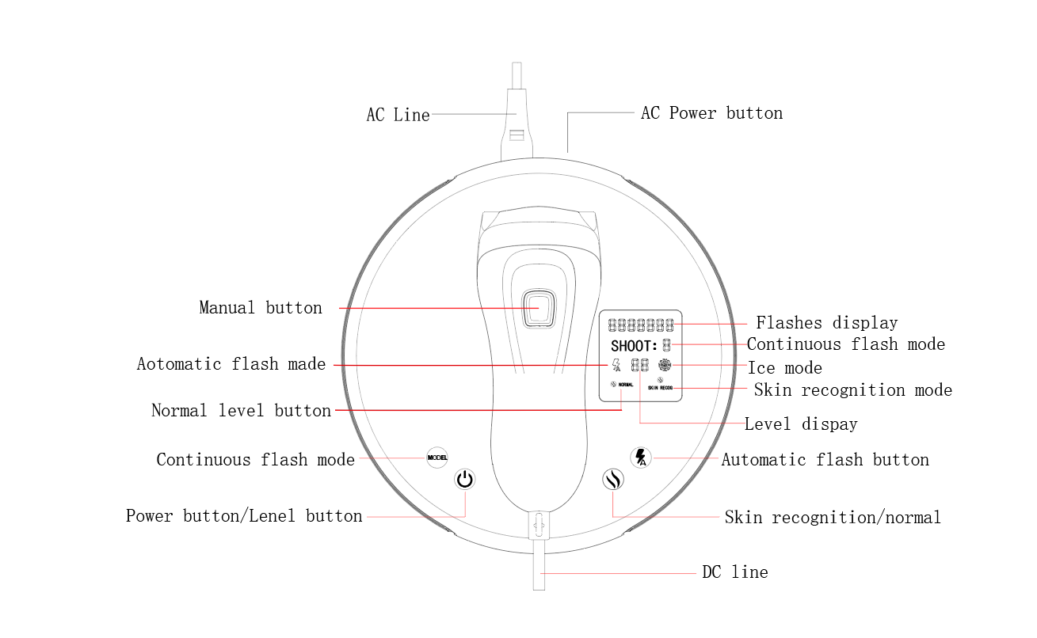

Image 1

# About Replaceable Head

1. Replaceable head is IPL device spares, according to body’s different areas using appropriate heads.

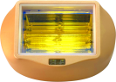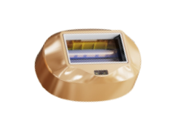 Window Area：9CM² Window Area：7CM²

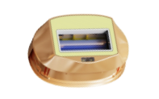

Ice Compress Area:4.5CM²

# 

# 98a503990d08bb4fb96ad54aeb30cb6

1. Please install the appropriate replaceable head onto the device in the direction of the arrow as indicated in the figure before using the equipment.

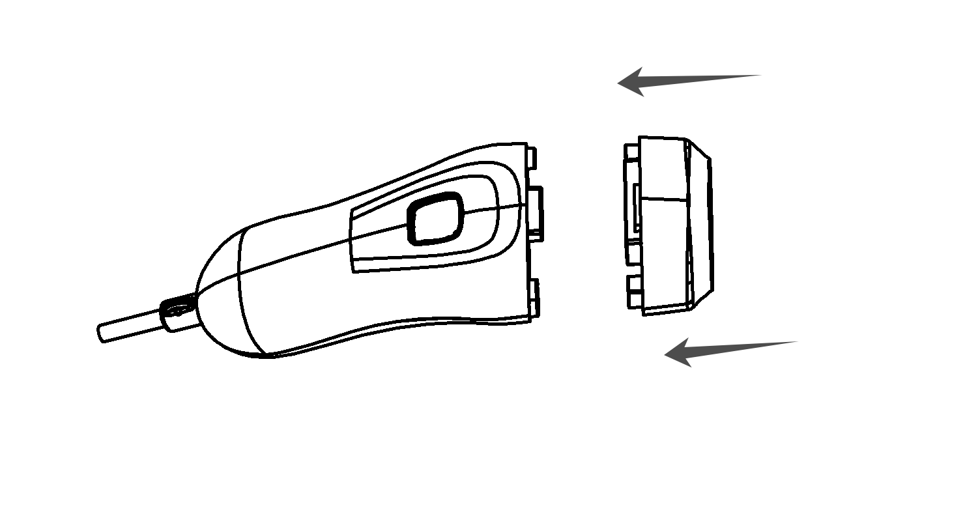

Image 2

# 4.Expected Function And Scope Of Application

1. Expected Function:A therapy to reduce or inhibit hair ,improving Skin Appearance)
2. Applicable Environment ：This device can be used in medical institutions、clinics、beauty salons and homes, the environment temperature is 5℃~40℃,relative humidity 25%~75% and air pressure 86.0kPa～106.0kPa, the power supply is AC100V~240V, 50Hz/60Hz, 1.5A, please not use under the direct sunlight
3. Applicable Group：It’s suitable for 18-year or above , Choose different levels 、skin and hair color

|  |  |  |  |  |  |  |
| --- | --- | --- | --- | --- | --- | --- |
| Skin Mode  Body Area | White | Ivory | Beige | Light Brown | Brown | Dark Brown and Black |
| Ⅰ | Ⅱ | Ⅲ | Ⅳ | Ⅴ | Ⅵ |
| Underarms | 4-10Level  Using3-4 Times | 4-8Level  3-4Times | 3-7Level  Using3-4Times | 2-6Level  Using2-3Times | 1-4Level  Using2-3Times | Inappropriate |
| Arms | 4-10Level  Using3-4Times | 4-8Level  Using3-4Times | 3-7Level  Using2-3Times | 2-6Level  Using2-3Times | 1-4Level  Using2-3Times | Inappropriate |
| Legs | 4-10Level  Using3-4Times | 4-8Level  Using3-4Times | 3-7Level  Using2-3Times | 2-6Level  Using2-4Times | 1-4Level  Using2-3Times | Inappropriate |
| Lip Surrounding | 4-10Level  Using3-4Times | 4-8Level  Using3-4Times | 3-7Level  Using3-4Times | 2-6Level  Using2-4Times | 1-4Level  Using2-3Times | Inappropriate |
| Head and Face | 4-10Level  Using3-4Times | 4-8Level  Using3-4Times | 3-7Level  Using3-4Times | 2-6Level  Using2-3Times | 1-4Level  Using2-3Times | Inappropriate |

Image 4

Comparison table of level and using times

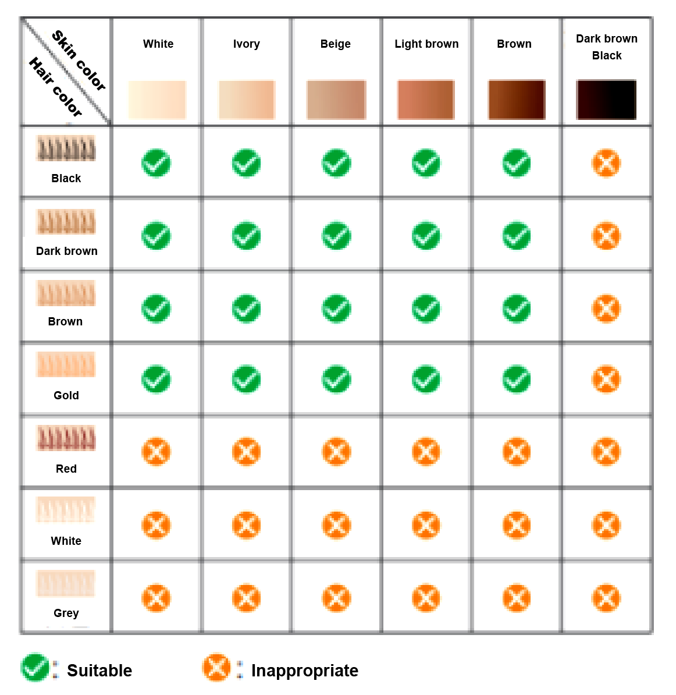

Image 5

Comparison of skin color and hair color

# ５、Skin Testing

* Before using the device, please use skin color card (Image 5)to distinguish the operation area skin mode,please refer to level and using times table(Image4) to test small area 24 hours ahead, in order to check if have any negative reaction.
* Testing Method
* When using this product for the first time,please choose a small area inner side of arm, from low to high energy level to test separately (Lighting the same area 1-2times).If have any negative reaction within 24 hours , please not use again before consulting doctor or customer service, if without negative reaction in your skin within 24 hours, feel the strong sensation of heat when you test, you just need to down a level to use )

# 6、Instrument Adjust

Step1:Before operation, to make sure the device clean and dry /intact, you can use alcohol pad or cotton stick to clear the window, therefore the hair and dust can be cleaned it up.

Step2:Using adapter AC plug insert power socket and DC connect device

Step3:Long press on the power icon 1 second, device indicator light start , and the window touch skin then the indicator light start , which means the device can work as normal.

# 7、Preparing Yourself

Before using, make sure your skin is in good condition , there is no damage and cuts,waiting for operation’s area hair shaving , skin is clean and dry(No residue of foundation cream make-up,antiperspirant or deodorant of any kind)

# 8、Operation instruction

a）Power Button(Second button on the left):Long press 1 second to Switch ON/OFF

b) Continuous flashes mode (First button on the left ):Short press to switch 1/3/6 continuous flashes mode.

c) SKIN RECOG／ NORMAL Mode：Third button from left to right,short press to switch skin recognition or normal mode, when using skin recognition mode, skin touch the window then device will test and switch level automatically , it will resume level 0 when skin is not in contact with window. Under the normal mode, user can choose level manually.

d) Automatic flashes button(the forth button from left to right):Short press to switch automatic flash/manual flash mode, default manual flashes when power on

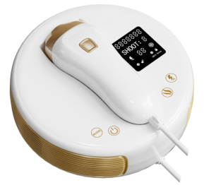（Image 6）

**How to use?**

Pressing the manual button to light, device will emit light once,with a subtle sound, it belong normal noise for the machine, if you feel light heat and sting feeling , it is normal.

Keep the window touch skin vertically(Image6) , waiting for the indicator show again then choose other areas to flash, please not treat the same area too closely or big interval.

3 When operate , Be careful not to overlap spots or miss operations, the whole area finished and then start the second times, total 2-3 times, the energy level from low to high, whichever is more bearable.

Remark:Comparison of the recommended operating levels and times for different parts of the skin under each type of skin (Image 5)

Hair removal procedure (Image 7)

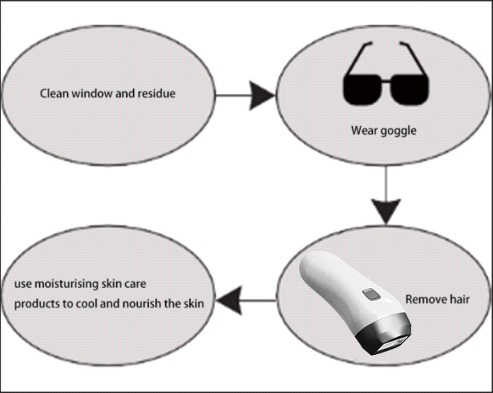

(Image7)

# G. Period Of Use

# In the weeks following the initial use of the instrument, the hair still grow, because IPL is effective for the hair in the growth phase,some hair are in dormant or degenerated period, so need to maintenance later

# 2-3 times per week for the first month,after 4 operations, you will find the treat area’s hair get thinner and soft, its color also get light, besides, the hair grow slowly .

# 。Weekly operation from the 2nd month, you will find the treat area’s hair reduce obviously , it doesn’t even grow anymore, Subsequent operations can be performed at intervals of 2-3 months if thin hairs grow out.

# H . Aftercare

# 1）It is recommended to avoid touching water for 6 hours after the hair removal operation, after which you can use moisturising water to moisturise the irradiated area.

# 2）Do not use perfume, masks or make-up containing abrasive beads after hair removal.

# 3）Please avoid direct UV sunlight on the treated area for 48 hours after the operation, and wear sunscreen when going out.

# 4）Artificial tanning is not permitted during a hair removal operation.

# 5）Please consult your doctor if you require cosmetic surgery after hair removal (hair removal area only).

# 6）Consult your surgeon if you feel unwell

# I . frequency of use

|  |  |  |  |
| --- | --- | --- | --- |
| Time | 1-4 Week | 5-8Week | After the 8th Week |
| Frequency | Use 3-4 times per week | Use 2-3times per week | Semi-monthly or monthly use |

# Image 8

# Remark:Please use several times according to the hair growth.Heavy hairs can be increased in gear and frequency as appropriate on this basis, depending on the individual.

# ９、Instrument Maintenance

# When the operation is complete, press and hold the power button again for 1 second to switch off the device and unplug the device at the end of each operation. Please note that if the device is left idle for more than 5 minutes, the device will switch off automatically.

# It is recommended to clean the light outlet with alcohol pads or cotton swabs before and after each use.

# Keep the Photon Beauty Device dry. Do not immerse the device or any of its parts in water to avoid the risk of electric shock.

# Instrument Storage

# To avoid damage or loss of the equipment and its accessories, return the instrument and its accessories to the case after each use.

# Please clean the device and store it in a safe place. Failure to do so may affect product functionality

# １０、Fault Resolution

When the device fails during use, users can follow the following guidance to troubleshoot some simple faults; if the problem still cannot be solved after completing all steps, please contact the company's customer service department for solutions.

* Unable to Start

Please check if the adapter is well connected.

* Unable to Flash

Please ensure that the light outlet is in correct contact with the skin and the power/indicator light is always on and restarting the device.

**1１、Safety Protection Measures**

* Please read these safety precautions carefully first and then follow the user manual. These safety protection measures are to ensure the correct and safe operation of the product to prevent personal injury or property damage to users or other persons, and please be sure to comply with these regulations.

**Contraindications**

* This device is for use by persons at least 18 years of age.
* The pregnant women during pregnant period, the females who try to get pregnant or during lactation are not suggested to use it, the device hasn’t made relevant test to females during gestation period and lactation. Hormone’s change may increase skin’s sensitivity or skin’s discomfort probability.
* Persons with a history of allergies should not use the device.
* Individuals with a known skin disorder/disease, such as allergic dermatitis, eczema ect.
* Individuals with sensory disturbance of skin.
* Individuals with black or fuscescent nevus.
* Individuals with broken skin, scab or healed wound, skin cancer or hemangioma.
* Individuals who have been treated, or receiving current treatment, with Alpha-Hudroxi Acids (AHAs), Beta-Hydroxi Acids (BAAs), Retin-A, tartaric acid, salicylic acid type of azelaic acid.
* Individuals who are taking isotretinoin.
* Individuals with large freckles, moles or blisters on the treatment area.

**Warnings**

* Hair removal by lasers or intense pulsed light sources can increase hair growth in some individuals. Based upon currently available data, the highest risk groups for this response are females of Mediterranean, Middle Eastern, and South Asian heritage treated on the face and neck. This group should be careful.
* Keep the product beyond children's reach.
* Do not subject the equipment to heavy shocks to avoid risk of damage to the lamp.
* Always unplug the appliance after use and in case of a power failure to avoid risk of damage to the equipment.
* Do not leave the equipment unattended when it is switched on to avoid the risk of fire or burns.
* If your skin has recently been artificially or naturally tanned or is burned from sun overexposure do not use the device. Contact your healthcare provider for advice with regard to how long to wait before using the device again.
* Do not expose treated areas to the sun. Wait at least one week after treatment before exposing treated skin to direct sunlight. Your skin may be extra sensitive following treatment and particularly susceptible to sunburn.
* Do not use the product on tattoos and skin areas with dark brown and/or black spots such as birthmarks, moles or warts, as these parts may excessively absorb luminous energy and cause skin damage.
* Do not use the product directly on the ears, neck, nipple, genital organ or perianal part, these parts’ skin is sensitive and easy to be destroyed.
* Do not use the device in or near bathroom, shower or any other places where the device may be stained with water.
* Do not expose the device to fire, high temperature heat source, or inflammables.
* Do not store the device in places of strong magnetic field, excess moisture and dust, or high temperature.
* Do not continue to use the device when the plug or power line is broken, out of shape, or cracked, this may result in injury.
* Do not try to open the device, as this may expose you to dangerous electrical components.
* Do not disassemble, repair, or transform the device without authorization, the private disassembly maintenance is forbidden.
* Operate the device according to the instructions in this manual.
* This product should only be used by one person during the product’s lifetime.
* Eye Safety:
* The device emits flashes of Intense Pulsed Light. Though the device has been tested for conformance with international standards to help ensure safety, direct exposure of the device’s output to eh eye could cause permanent eye damage. The device contains a skin contact sensor to help prevent light output unless the device is in contact with the skin. However, DO NOT USE THE DEVICE OVER THE EYES, ON EYELIDS, EYE BROWS, OR NEAR THE EYES.
* DO NOT look directly into the light-emitting window of the device when the device has electrical power and is switched on.
* DO NOT attempt to flash (emit light) the device towards the eye.
* ONLY attempt to flash the system when the light-emitting window of the device is in good contact with the area you wish to treat.
* WE RECOMMEND you look away from the device when flashing onto your skin.

# 1２、Operation Precautions

* This product is not recommended for use by persons with physical or mental illness or who are undergoing dermatological treatment unless used under the guidance of a professional or dermatologist.
* Please keep this product away from children.
* During use, do not cover the air inlets and vents to avoid affecting heat dissipation.
* Slight redness is normal during the procedure. It is recommended to use ice packs for relief.
* Before using the device, use alcohol cotton pads or cotton swabs to disinfect the area around the light outlet, but do not spray alcohol directly on the light outlet.
* During operation, please do not apply gel or other cosmetics to the operating area to avoid damaging the device.
* Avoid UV exposure while using the device. Moisturizers and sunscreen can be used to protect the skin from the sun and computer radiation.
* After using the device, use alcohol cotton pads or cotton swabs to disinfect the area around the light outlet, but do not spray alcohol directly on the light outlet.
* During operation, if hair or stains stick to the plastic at the edge of the light outlet, black spots will appear. But it does not affect the function and use of the product.
* After long-term use, it is normal for the inner wall of the outlet to darken; at this time, the device can still be used normally. If the function of the device is affected, please contact us and our technicians will repair it for you.
* This product must not be used in the bathroom or shower, or in any other place where water may enter the device.
* If the device accidentally gets wet or comes into contact with water, please send it back to the factory for inspection. We will determine if the device is repairable.
* If the device gets wet while it is powered on, for your safety, please turn off the power before touching the device.
* Avoid storing the device in places with strong magnetic fields, radio waves and high temperatures.
* Do not strongly impact or knock the device.
* Do not use this product for purposes other than those permitted by the instructions for use.
* Do not use the device if it is damaged; for example, the main body is broken, the wires are damaged (internal wires are exposed), the main glass is broken or damaged, etc. Electric charges on internal components may cause danger.
* Do not use a power supply beyond the 100-240V range to charge the device. If the power cord or power interface is damaged, deformed or cracked, stop using the device immediately.
* ● Do not maintain or repair device while in use by users.
* The user is the intended user of the device and can perform maintenance on the device.
* Do not use excessively long cords or hoses to avoid the risk of strangulation.
* All materials that come into contact with the human body have been tested for biocompatibility and meet biocompatibility requirements
* The device's push-in plug is a disconnect device. Do not place the device in a position that is difficult to operate.
* If the user requires additional information such as circuit diagrams, parts lists or product descriptions to be provided to a qualified technician, please contact us.
* Between the operation gap,The minimum time for equipment to warm up or cool down from storage temperature to ready for intended use is 18 minutes.
* If any abnormality occurs during use, please unplug immediately.
* Except for personnel authorized by our company, no other personnel may attempt to disassemble the device, otherwise there is a risk of electric shock.
* ：Eye Protection:
* The photon hair removal device emits flashing intense pulsed light. Although this device has been tested and complies with international standards to ensure that its output is safe for the human eye, direct exposure is still potentially harmful to the human eye. Although the device can only flash (emit strong pulsed light) when the skin sensors on both sides of the device (located inside the light outlet) detect that the device is close to the skin. But still need to pay attention to:
* When the device is powered on, do not look directly into the light outlet of the device.
* Do not attempt to flash the device (emits strong pulsed light) directly into your eyes.
* Do not use the device on the area around the eyes (eyebrows or eyelashes).
* First make sure the light outlet of the device is fits the skin, and then start flashing.
* We recommend looking away when the device flashes the light towards your skin.

# 1３、Not applicable to the following situations

* Not suitable for people under 18 years old. The effects of this product on this age group are unknown.
* Not suitable for use during pregnancy, lactation or menstruation.
* Not suitable for people with scar constitution.
* Not suitable for patients with a history of light sensitivity or diabetes.
* Not suitable for patients with heart disease, hypertension, folliculitis, malignant tumors or anticoagulant disorders.
* Not suitable for those who are receiving essential oil therapy.
* Not suitable for those taking aspirin or immunosuppressants.
* Not suitable for people who have been exposed to sunlight in the past two weeks.
* Not suitable for sensitive parts such as mucous membranes; not suitable for upper eyelids, lips, nipples and other private parts; not suitable for tattoo areas.
* Not suitable for hirsutism and other diseases that may cause complications.

# 1４Disposal (scrap)

* Please hand the scrapped photon hair removal device to the official recycling point for recycling (you can contact local municipal personnel for recycling information), and do not throw it away with ordinary household waste. This move helps protect the environment.

# 1５、Warranty content

**A Disclaimer**

* Our company reserves the right of final interpretation of the photon hair removal device. Any third party may not use equipment-related information without the authorization of our company, otherwise we will take legal action. Under any circumstances, our company will not be responsible for any consequences caused by improper use.

**B Warranty**

* 1) Warranty period
* The warranty period of this product is 1 year from the date of purchase.
* 2 ) Covered Under Warranty

If the device is within the warranty period, our company will repair or replace the product for you free of charge. Other failures due to improper use and force majeure are not covered by the warranty.

* 3) Warranty limitations

When applying for free maintenance of products within the warranty period, users should present a valid invoice. The warranty period of our products starts from the date of purchase shown on the invoice. If there is no purchase date on the invoice, the warranty period starts from the production date.

* When you return the instrument, free maintenance is not provided for damage caused by improper placement on your part.
* If the device repaired by our company's maintenance center is still within the original warranty period, you can continue to enjoy the maintenance services provided by our company.
* the replaced faulty parts will be retained by our company.
* Users should keep product invoices properly and our company will not issue invoices again.
* The company is not responsible for the following situations and does not provide warranty services under the following situations:：
* Failure or damage caused by fire, earthquake, third-party actions, improper use by users, use under other abnormal conditions, and unpredictable events.
* Incidental losses caused by the use of products (such as loss of business profits, lost time, etc.), including expenses incurred by the user due to the use of instruments, replacement of equipment and services, and claims.
* Damage caused by failure to follow the user manual.
* Including: uncontrollable circumstances; the company no longer sells and provides services and parts required for repair; malfunctions caused by the use of spare parts or replacement parts not sold by the company; failure due to unauthorized disassembly and failure to assemble the instrument according to the instructions for use. resulting failure.
* 5)Product failure due to use in inappropriate working environment, including overload use.
* Damage caused by improper storage by the user (such as rat bites,liquid immersion,etc)

**Support and Help**

* Dear Users ,In order to provide you with more convenient services, if you have any questions about the photon hair removal device you purchased, please consult according to the following contact information.
* Contact number：4006-999-808
* E-mail：[Alushee@umaglo.com](mailto:Alushee@umaglo.com)

Certificate

|  |  |
| --- | --- |
| Name | Home Use Photon Hair Removal Device |
| Model | I3 |
| Production Company | Shenzhen Yangyi Technology Co., Ltd. |

After testing, this device complies with the various indicators stipulated in the product standards for household photon hair removal devices. After passing the inspection, we agree to leave the factory.

The quality department of Shenzhen Yangyi Co.,Ltd

Warranty Card

Dear Users:

Thank you very much for using I3. This coupon serves as the machine warranty certificate. In order to allow you to better enjoy after-sales service, please keep it properly for use during maintenance. Thank you!

|  |  |  |  |  |  |
| --- | --- | --- | --- | --- | --- |
| Client's Name |  | | | | |
| Phone Name |  | Store Name |  | | |
| Contact Address |  | | | | |
| Product Model |  | Purchase Date |  | Instrument Code |  |
| Fault Description |  | | | | |
| Fault Description |  | | | | |
| Maintenance Status |  | | | | |
| Maintenance Staff |  | Inspection Personnel |  | Repair Date |  |
| Maintenance Records |  | | | | |

Remark：

1. The warranty period of this product is 1 year from the date of sale (excluding special accessories, please see the "Warranty" section of the manual for details).

2.2. If the user causes product damage due to human factors, or the warranty period is exceeded, the company will charge a certain maintenance fee depending on the repair situation.

Product Name：IPL Hair Removal Device/I3 Mode

Registrant：Shenzhen Yangyi Technology Co., Ltd.

Registrant’s Address：601, Building 1, No. 2, Rongshu Road, Qiaotou Community, Fuhai Street, Baoan District, Shenzhen City

Tel:400 6999 808

E-mail:Alushee@umaglo.com

Website:www.yangyi1688.com

After-sales:Shenzhen Yangyi Technology Co.,Ltd

Manufacture:Shenzhen Yangyi Technology Co.,Ltd

Customer Service Hotline:400 6999 808

Customer Service email:Alushee@umaglo.com

Date of preparation or revision of the manual:June 6, 2024

Manual release version number: V1.0