**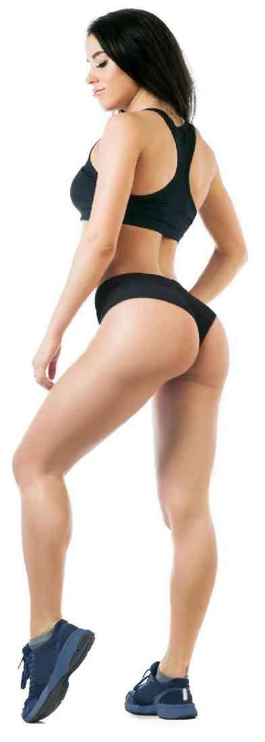**

**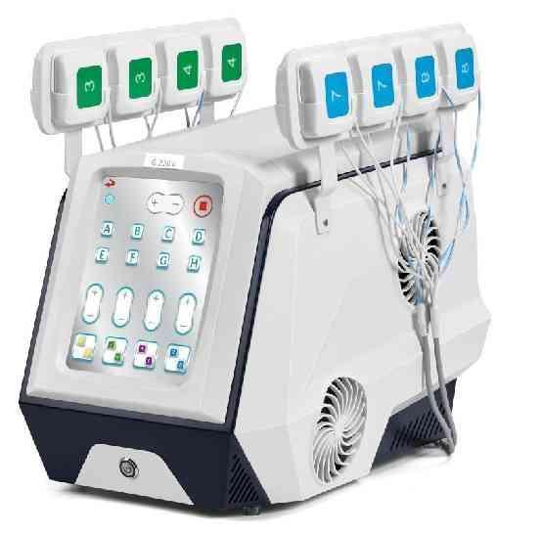**

**Body Sculpting EMS**

Be sure to read the instruction manual carefully and follow the instructions before use.

**Product Introduction**

**Ⅰ**

Welcome to choose our company's latest product:Body Sculpting EMS, which is a new generation of non-invasive muscle-building, fat-reducing, and shaping equipment. It uses (EMS) electrical pulses to stimulate the continuous expansion and contraction of target muscle groups, thereby increasing muscle mass and endurance. and strength.It can be used to firm and strengthen abdominal muscles, arms, legs and buttocks.The Body Sculpting EMS can treat up to eight separate areas at the same time. The 16 handles are placed on multiple body areas or multiple muscle groups depending on your individual needs and goals. In the traditional way of exercise, muscle contraction and action are done by the brain sending signals to the nervous system and motor neurons to control the muscles.Body Sculpting EMS simulates the brain signals of the human body, and transmits motion signals directly to specific muscle groups through the handle, so that it induces rhythmic muscle contractions, and provides a more complete exercise with extremely high precision to strengthen and tighten. to muscles.Unlike other devices, both the front and back of the body can be treated simultaneously, and Body Sculpting EMS can also stimulate multiple muscles in a single treatment and provide more efficient and specific energy delivery to the targeted muscles. It is three times stronger than other muscle stimulation devices on the market, and is more comfortable for clients with superior results, as well as greatly improving the safety of the treatment. Safe and effective solution for men and women seeking to improve the shape, size and firmness of their abdomen or buttocks.

**Working Principle**

**Ⅱ**

The principle of Body Sculpting EMS is to release high-intensity electrical pulse energy through the electrode handle to directly transmit the deep muscles, stimulate the target muscle motor neurons, make the muscles contract continuously and rapidly, increase muscle tension, mass and strength；Body Sculpting EMS electrical pulse technology allows the human body to produce passive movement, so to achieve the purpose of muscle growth and fat reduction ,loss weight and shaping.

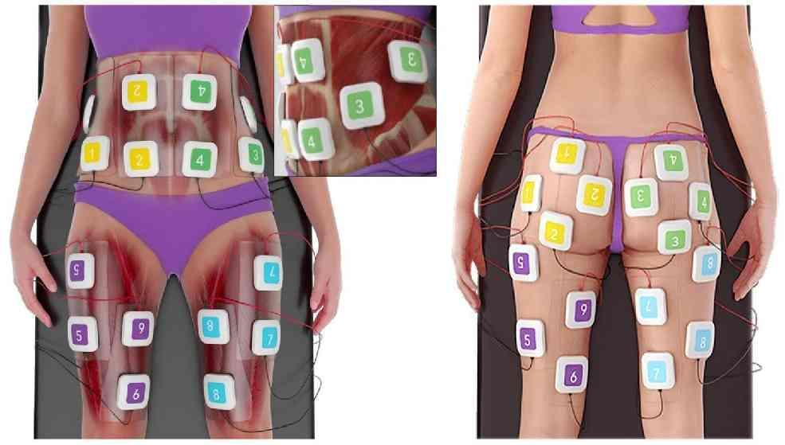

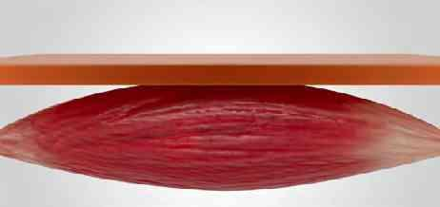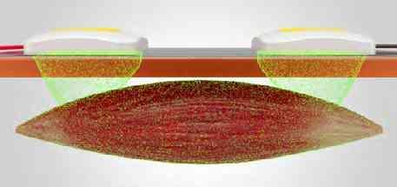

**Device Features**

**Ⅲ**

Faster and more efficient

Non-invasive, safe , comfortable

During the treatment, only muscle contraction is felt, the process is easy and comfortable, and there is no side effect on the body, just do it and go.

Treating up to eight areas simultaneously at a time improves body coverage and provides more efficient and comprehensive muscle activation.

Flexibility handle

The 16 handles provide multiple different body parts options to customize treatment for multiple muscle groups.

Time-saving and efficient

1 session of 45 minutes = 54000 muscle contraction exercises; versus 54000 crunches/squats.

Simple operation

Higher efficiency

Equipped with a special gel pack to fix the handle to stabilize energy transmission and improve safety and effectiveness.

A treatment of 30% muscle gain and 25% fat loss.

Manual Mode-Custom Loop

Auto Mode - Smart Loop

In manual mode, 1 to 8 frequencies can be freely selected, and various responses are triggered according to the selected therapy frequency.

Provide automatic multi-frequency combination mode therapy for targeted muscle areas.

Tailored energy control system

Targeted regional energy adjustment, and customized energy stages for each part.

**Device Indication**

**Ⅳ**

1. Align the handle with the corresponding socket at the rear of the device, insert it and place it well;

## Insert the power cord into the rear socket of the device, turn on the power and turn on the power switch, and then press the power button to turn on the device.

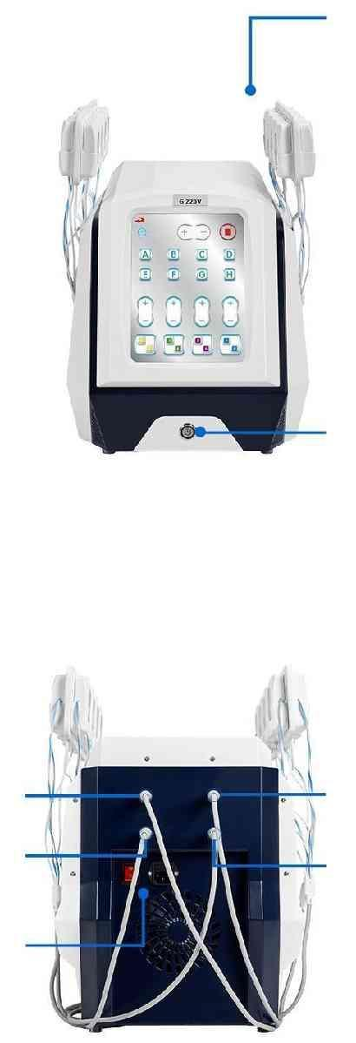

Work Handle

Power button

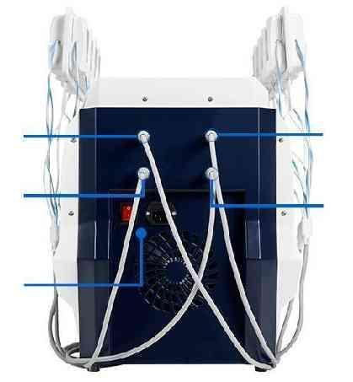

No.3 and No.4 handle socket

No.7 and No.8 handle socket

No.1 and No.2

handle socket

No.6 and No.6

handle socket

Switch/Power Cord Socket

**Accessories**

**Ⅴ**

• Two electrode handles with the same number are a group; one positive and one negative.

No. 1 Handle

No. 2 Handle

No. 3 Handle

No. 4 Handle

No. 5 Handle

No. 6 Handle

No. 7 Handle

No. 8 Handle

×2

×2

×2

×2

×2

×2

×2

×2

• A pack of 6 • Gel Pack.

• For external use only, single use only.

• The gel pack is a conductive medium that reduces discomfort and maximizes safety and efficacy.

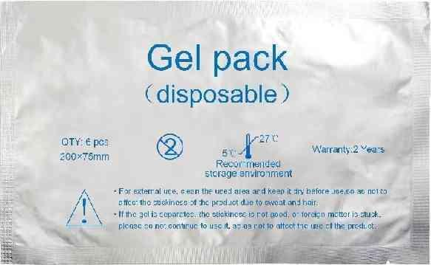

**Interface Introduction**

**Ⅵ**

1. The startup interface (Figure 1) will appear after booting up, click Figure 1 at random to enter the Figure 2 interface.

G:\资料采集\EMS   (truSculpt-flex)\资料\说明书编辑\8(1).png8(1)2. After selecting the setting (male or female, age, fat thickness) user information in Figure 2, click to enter the Figure 3 interface.

Figure 2: Setting information interface

Figure 1: Boot interface

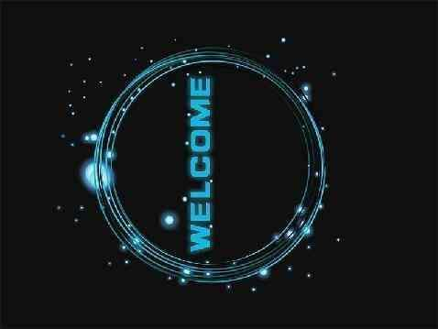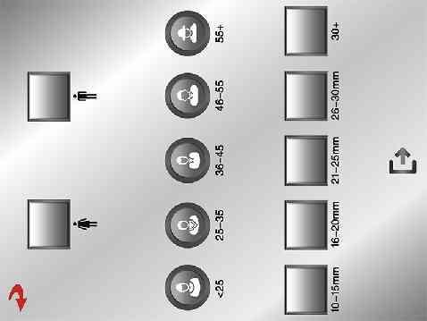

Female

Male

Age Selection

Adipose Thickness

Click to enter the next interface

3.After clicking the automatic/manual mode in Figure 3, you can enter the next interface.

Figure 3: Mode selection interface

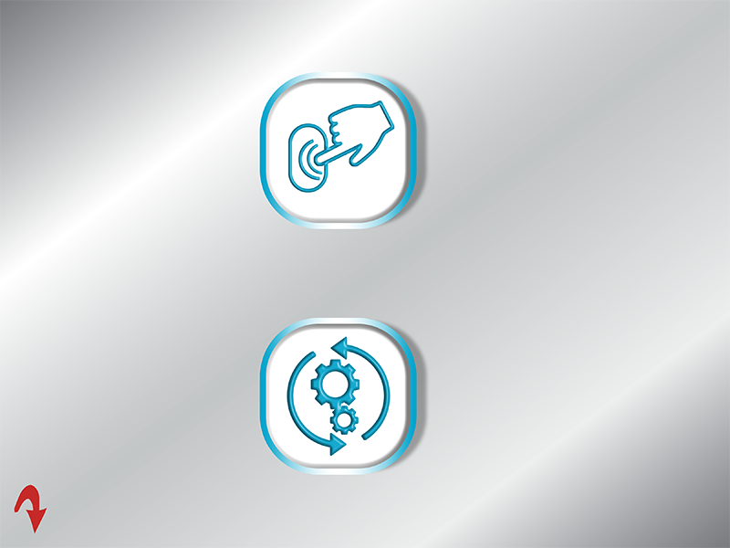

Manual Mode

(Click this icon to enter Figure 5)

Automatic Mode

(Click this icon to enter Figure 4-1)

4.Select the automatic mode in Figure 3 to enter the working interface (Figure 4-1).

Figure 4-1: Work Interface

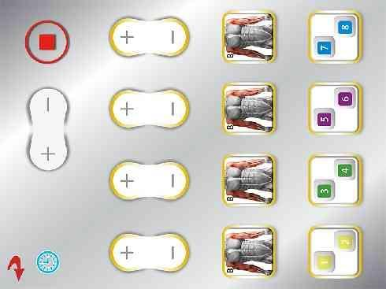

Operating Hours

30:00

(click "+" "-" to adjust)

Start/Pause

**No.7 & No.8**

**Handle Energy**

**No.1 & No.2**

**Handle Energy**

18

10

11

05

(click "+" "-" to adjust)

**No.5 & No.6**

**Handle Energy**

**No.3 & No.4**

**Handle Energy**

The picture shows the

training mode selected by the handle

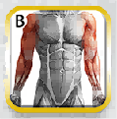

Select the desired training mode before treatment.

Click to enter (Figure 4-2) to select the desired training mode.

Figure 4-2: Select Mode Interface

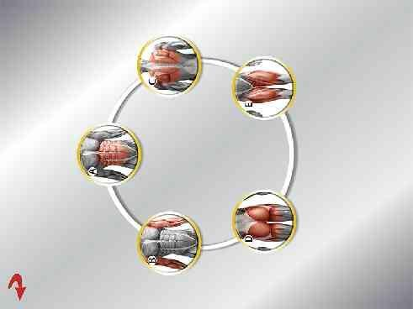

Basic training for beginners

Adaptation Training

Preliminary Training

Advanced Training

Professional Training

• Each training mode contains 6 kinds of frequency automatic cycle.

• Note: Click the icon to select this mode, and automatically enter Figure 4-1 after selecting the mode.

• The working interface (Figure 4-1) is described as follows:

G:\资料采集\EMS   (truSculpt-flex)\资料\说明书编辑\界面\DD_SET-1024X768\13.bmp13

05

• “ ”Indicates energy adjustment, the energy range is 00-30; click "+" to add, "-" to subtract.

Note: When the device is in a suspended state, click "+" to add or subtract "-" to adjust.

Remarks: The energy is set before the operation, the treatment starts from low energy, and the energy should be gradually increased according to the patient's ability to bear.

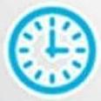• " "For working hours, click "+" to add and "-" to subtract.

G:\射频\说明书编辑\界面\暂停按钮1.jpg暂停按钮1G:\射频\说明书编辑\界面\启动开始按钮1.bmp启动开始按钮1• Click" "turn to" "Indicates that the device starts to work.

G:\射频\说明书编辑\界面\启动开始按钮1.bmp启动开始按钮1G:\射频\说明书编辑\界面\暂停按钮1.jpg暂停按钮1• Click" "turn to" "Indicates pause, the device is in standby state.

G:\射频\说明书编辑\界面\返回按键.jpg返回按键• Click " " to return to the previous interface.

• The equipment consists of four core electrode cables, each core electrode cable consists of 4 electrode handles,you can choose 4 handles, 8 handles, 12 handles, and 16 handles to work at the same time.

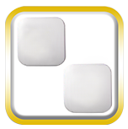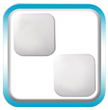• When the energy is adjusted, it starts to work, and the yellow frame of the handle icon“ ”turns into“ ” “ ”. The blue and yellow flashing alternately indicates that the handle is in working state.

5. Select the manual mode in Figure 3 to enter the working interface (Figure 5).

Figure 5: Work interface

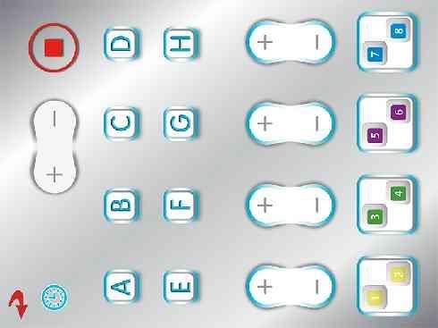

Operating Hours

30:00

Start/Pause

(click "+" "-" to adjust)

Operating Frequency

(1-8 frequencies can be selected）

18

10

11

05

**No.1 & No.2**

**Handle Energy**

**No.7 & No.8**

**Handle Energy**

(click "+" "-" to adjust)

**No.3 & No.4 Handle Energy**

**No.5 & No.6 Handle Energy**

Select the required working frequency before Therapy,up to 8 operating frequencies can be selected.

• The working interface (Figure 5) is described as follows:

• Select the working frequency before operation, up to 8 frequencies (A-B-C-D-E-F-G-H).

After each frequency works for 1 minute, it will automatically jump to the next frequency stage to work, and cycle until the equipment working time is completed.

“ ”The first frequency stage:5Hz;

“ ”The second frequency stage:17Hz;

“ ”The third frequency stage:80Hz;

“ ”The fourth frequency stage:120Hz;

G:\资料采集\EMS   (truSculpt-flex)\资料\说明书编辑\18(E).png18(E)“ ”The fifth frequency stage:160Hz;

“ ”The sixth frequency stage:180Hz;

G:\资料采集\EMS   (truSculpt-flex)\资料\说明书编辑\18(G).png18(G)“ ”The seventh frequency stage:200Hz;

“ ”The eighth frequency stage:300Hz;



• When the gray frame “ ” turns into “ ”, the blue frame is always on, indicating that this frequency is selected. 1-8 frequencies can be selected.



•When the “ ” blue frame is flashing, it means that the current frequency stage is working.

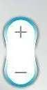• “ ”Indicates energy adjustment, the energy range is 00-30; click "+" to add, "-" to subtract.

05

Note: When the device is in a suspended state, click "+" to add or subtract "-" to adjust.

Remarks: Set the energy before the operation, and the treatment starts from low energy, which should be adjusted according to the patient's tolerance.

Gradually increase the energy.

• “ ” means working time, click “+” to add, “-” to subtract.

G:\射频\说明书编辑\界面\暂停按钮1.jpg暂停按钮1G:\射频\说明书编辑\界面\启动开始按钮1.bmp启动开始按钮1• Click " " turn to " ", which means the device starts to work.

G:\射频\说明书编辑\界面\暂停按钮1.jpg暂停按钮1G:\射频\说明书编辑\界面\启动开始按钮1.bmp启动开始按钮1• Click “ ”turn to “ ”, it means pause, the device is in standby state.

G:\射频\说明书编辑\界面\返回按键.jpg返回按键• Click“ ”Indicates to return to the previous interface.

• The equipment consists of four core electrode cables, each core electrode cable consists of 4 electrode handles,you can choose 4 handles, 8 handles, 12 handles, and 16 handles to work at the same time.

• When the energy is adjusted and the controller starts to work, the blue frame of the handle icon “ ” turns into “ ” “ ” and the gray and blue flashes alternately, indicating that the handle is in working state.

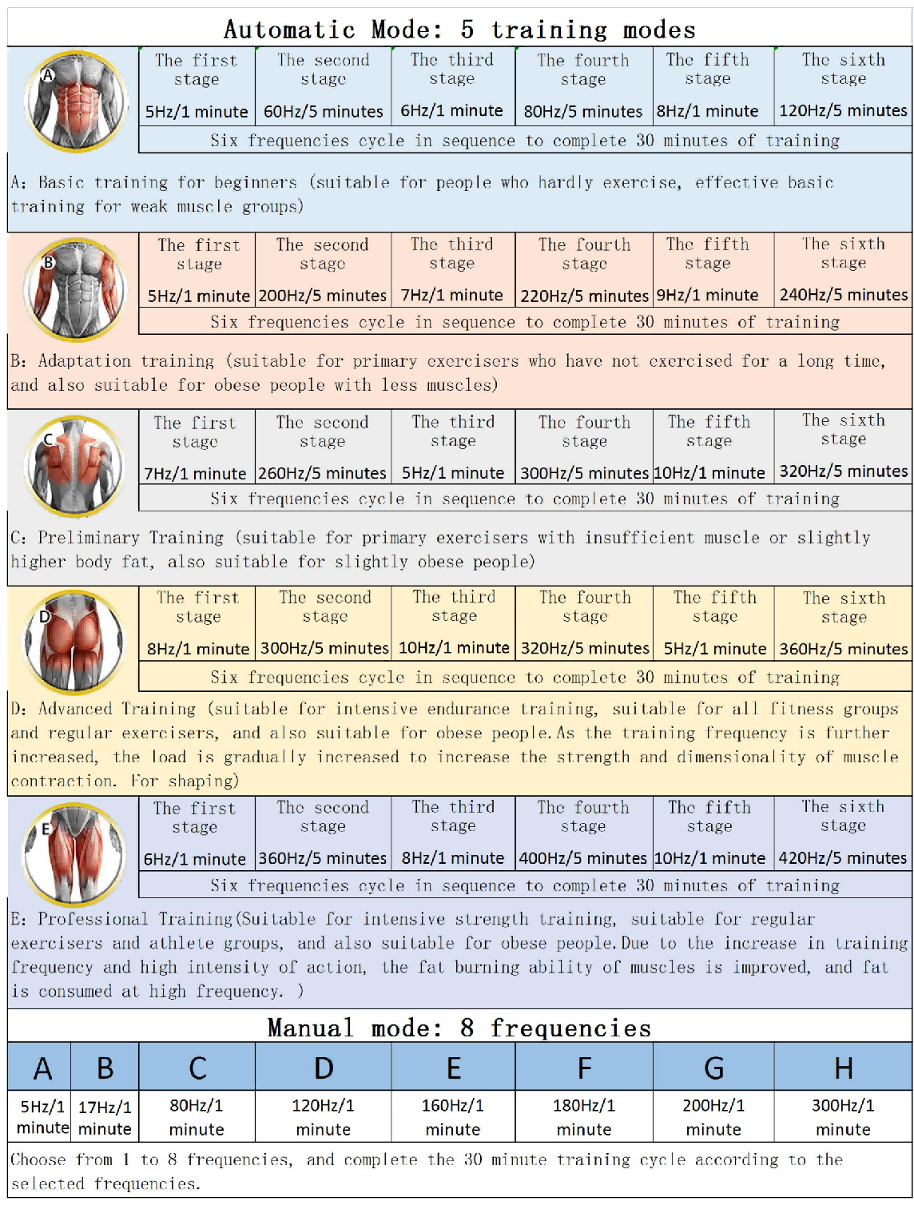

**Use Instructions**

**Ⅶ**



• Open the packaging bag , take out a gel pack, and peel off the transparent release film on one side.

• Apply the gel pack to the desired area, smooth and fit the skin.

• Remove the transparent release film on the reserved side, and then stick the handle on the gel pack.

• Handle placement guidelines:

- Correct placement: A handle of the same number must be placed on a piece of gel pack.

- misplaced.

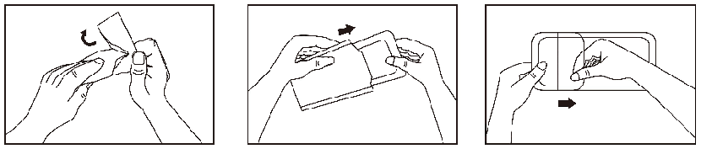

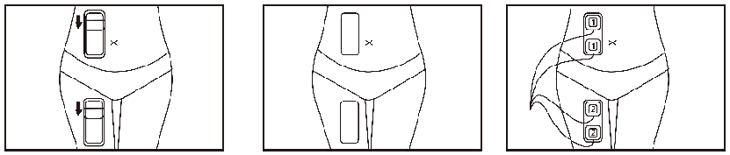

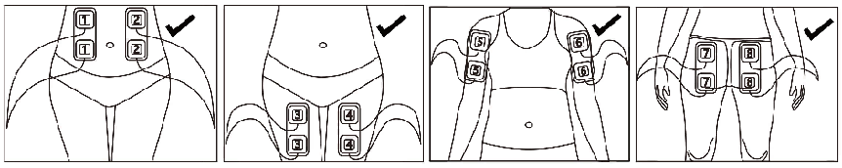

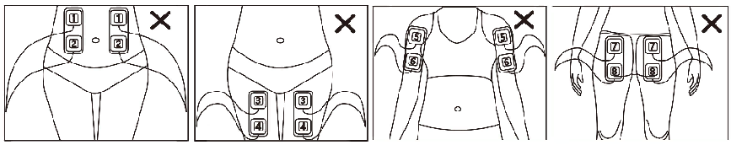

•Operation Steps:

- Before the procedure, clean the desired treatment area and keep the area dry.

- Before operation, remove the metal objects worn on the body.

- After the gel patch and handle are tightly attached to the skin, adjust

the parameters and then start the operation.

(Note: The handle and gel patch must be close to the skin, and there should

be no gaps to tilt the handle).

- Start with low energy and gradually increase according to the client's tolerance.

- After the operation, gently peel off the gel patch.

- After the operation, wipe the clean handle with a soft cloth and place it

back on the hanger.

- After the operation, you can drink more water to help metabolism, and you

can also eat foods with high protein content.

• Precautions:

- Do not place the handle on injured skin or infected muscle.

- Do not place the handle in the middle area of the belly button.

- Be careful to avoid obvious locations of ribs and bones.

- Do not operate on the head, neck/carotid artery, rich bag, or

near the chest gallery.

- No metal objects are allowed on the healer.

- Do not operate the abdomen when you are full, and it is

recommended to perform treatment more than 1 hour after a meal.

- Make sure that both the operating area and the treatment handle

are dry and free of water or (no) moisture.

**Ultrasound Results**

**Ⅹ**

•Ultrasound findings showed increased muscle mass and decreased fat following treatment.

**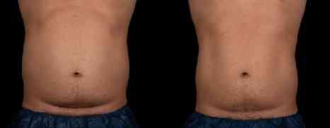**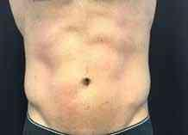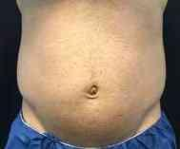

After 6 times Therapy

for 12 weeks

After 6 times Therapy

for 12 weeks

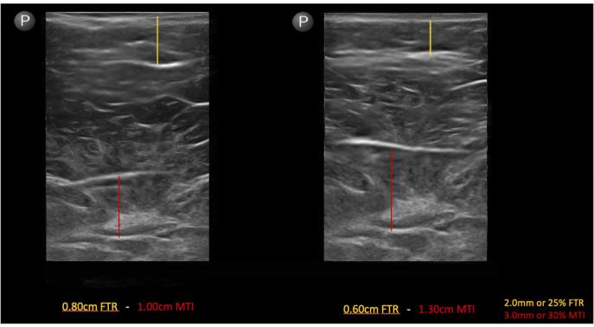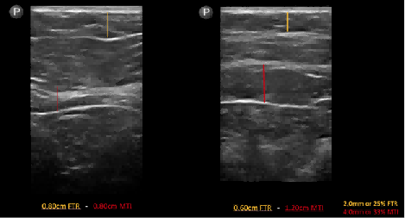

Before Therapy

Before Therapy

·Red line shows 33% increase in muscle mass. Yellow line shows 25% decrease in fat thickness.

·Red line shows 30% increase in muscle mass.Yellow line shows 25% decrease in fat thickness.

**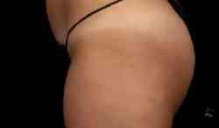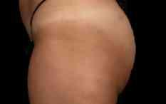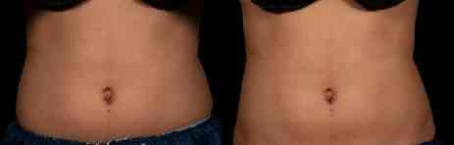**

After 4 times Therapy

for 8 weeks

After 6 times Therapy

for 8 weeks

Before Therapy

Before Therapy

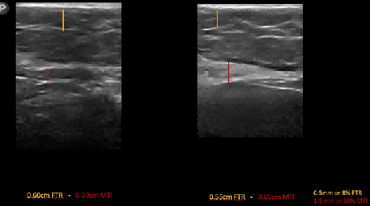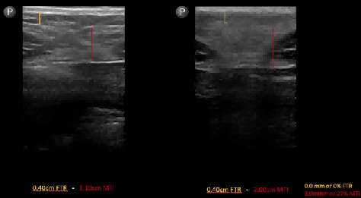

· Muscle mass increased by 30% and fat thickness decreased by 8%.

·Muscle mass increased by 27%.

**Common Problem**

**Ⅷ**

**1.What is Body Sculpting EMS ?**

Body Sculpting EMS is a personalized muscle sculpting device. The device consists of four core electrode cables, and each core electrode cable consists of 4 electrode handles, with a total of 16 working handles. The handle is placed on the body, allowing up to eight areas to be treated simultaneously. The Body Sculpting EMS has a variety of intensity settings and treatment modes, delivering electrical impulses through a handle placed on the skin over the muscles, simulating action potentials initiated by the nervous system, triggering rhythmic muscle contractions, and stimulating metabolism and blood circulation. Proprietary unique handle and gel patch deliver energy directly to stimulate muscle contraction without wasting energy.

Body sculpting EMS is an electrical impulse muscle stimulation device that uses electrical impulses to induce muscle contractions.

A specific muscle or muscle group can be contracted far beyond levels tolerated by traditional electrode pads.

As shown below, body sculpting EMS leverages many of the historical effects of traditional EMS, but is an innovation in electrode design because it applies a uniform current distribution along the length of the muscle.

Negative Electrode

Positive Electrode

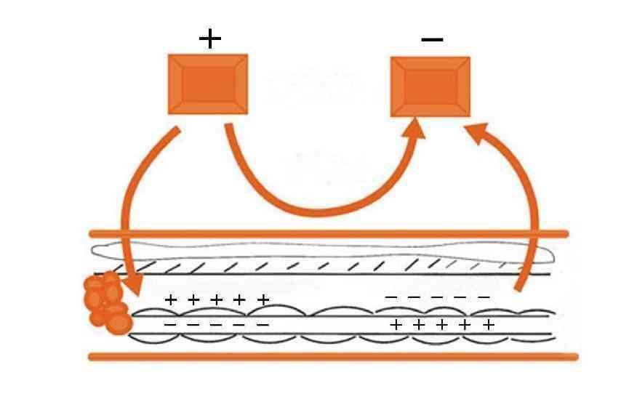

Electrode Handle

Electrical Pulse(current)

Skin

Depolarization

hyperpolarization

Nerve Bundle

Adipose

Nerve Fibers

Illustration of nerve depolarization using direct electrical impulse stimulation

1. **Who is suitable for Body Sculpting EMS ?**

This technique can provide beneficial muscle tightening for most people. Five suitable groups of people have been sorted out:

①Women who need to gain muscle and change their body shape - hip lift, vest line, and let women show their graceful posture in minutes.

②Men who need to increase muscle and change their shape - increase muscle, especially sculpt chocolate muscle.

③ People who need to lose weight - suitable for both men and women, more suitable for busy office workers

④People who need to lose weight and shape quickly - brides-to-be, models, actors, etc.

⑤ Postpartum mothers (rectus abdominis separation) - improve the shape of the abdominal muscles and shape a flat abdomen.

**3. What parts can Body Sculpting EMS be done at one time? How long does it take to treat a site?**

It can treat up to 8 different body parts simultaneously and takes approximately 15-45 minutes.

It is recommended that the abdomen, thighs and buttocks be treated for 30-45 minutes/time, and the arms and calves are treated for 15-20 minutes/time.

**4.How often do you do it? Do a course of treatment several times？**

Usually once every 2-3 days. 4-6 times as a course of treatment. The number and frequency of treatments needed depends on your size, fitness level, and goals. Most patients experience significant results in just four sessions, while others may require additional treatments for more individualized results.

**5.How does it feel to finish Body Sculpting EMS? Will the treatment hurt?**

At the start of treatment, patients experience muscle twitches or repetitive contractions that intensify as energy intensity is slowly increased. After treatment, you may experience a slight tingling sensation and some muscle soreness, similar to what you feel after vigorous exercise after treatment.

**6.When will I see the results?**

Results are usually visible 8-12 weeks after treatment. Best results are seen 8-12 weeks after the last treatment. To break down fat and increase muscle mass, patients need patience, usually after 4-6 treatments, clinical studies show that muscle mass is increased by about 30% after treatment, and fat is reduced by an average of 25%.

### 7.Is there any downtime?

The Body Sculpting EMS is non-invasive and requires no recovery time, allowing clients to resume normal activities immediately after treatment. After the procedure, guests may notice tingling in the treated area for several hours and/or mild muscle soreness or tenderness for 24-72 hours.

****8.How long do the results last?****

A:As long as you maintain your weight, remain relatively active, and participate in regular maintenance treatments, the muscle growth that Body Sculpting EMS produces is permanent. If you overeat, the chances of a lasting effect are less。

**9.Can Body Sculpting EMS be combined with other slimming treatments？**

A: Body Sculpting EMS can be combined with some non-traumatic fat removal care, such as Body Sculpting ID radio frequency fat dissolving instrument, cryogenic fat dissolving instrument, and laser air fat dissolving instrument, to eliminate more fat. In addition, it can be used in conjunction with some postpartum restorative treatments. For postpartum women's health and physical problems to improve.

**10.How soon can I use it after giving birth?**

A: It is recommended to wait until 6-8 weeks postpartum to fully recover before using it. Cesarean section is recommended three months after full recovery. Abdominal muscle separation can quickly help build muscle and repair rectus abdominis.

**11.Who can not receive Body Sculpting EMS treatment?**

People should not receive treatment if:

– Pregnancy, lactation

- Women's menstrual period

– The treatment area is excessively moist

– Malignant tissue near or above the treatment site

– Any wounds or infected wounds near or in the treatment area

– pacemakers, defibrillators, implantable metal or electronic devices

– Heart disease, high blood pressure, thyroid, malignant tumor, kidney failure, epilepsy

– Venous thrombosis, varicose veins, thrombophlebitis, arterial occlusive disease

– Recent surgery

– Abdominal or inguinal hernia

**Technical Specifications**

**Ⅸ**

|  |  |
| --- | --- |
| Product Name | Body Sculpting EMS |
| Display Screen | 10.4 inch touch screen |
| Voltage | AC110V/220V |
| Air Box Size | 65×45×69cm |
| Gross Weight | About 28kg |